**Basics of HTML –**

**What is the definition of HTML?**

**HTML** is a **Hypertext markup language**. It is use for designing web pages which is to be displayed on the web browser. HTML Describes the structure of a web page that how your web page looks like. “**Hypertext**” is nothing but the hyperlinks that your html page contain. HTML is all about use of different tags which is written into a text file. The text is then saved as html file with .html or .htm extension and you can see the output of your html code on different browses like internet explorer, google chrome, edge etc.

**What is html tag?**

HTML tag is a root of your html document. HTML tag can be written with the help of angle brackets (<) and (>). All HTML Tags starts with <tag> and ends with </tag>.

**For example**- <tag> </tag>

**Basic HTML tags are used to define HTML Structure-**

**<!DOCTYPE html>** - This tag is use for declaration purpose. It Helps the web browser to identify the given web page is written in the markup language.

**<html>** - This is a root of HTML. All the content that will starts within html and html tags will be displayed on the web page. html code starts with the <html > and end with </html>.

**For Example**-<html > </html>.

**<head>** - Head tag is use to show specific information about your web page. For Example- Document title, style, link, script etc.

**<title>** - Title tag is use for providing title for your web page. Which you can see in browser link.

**<body>** - Body tag consists of total html contents like Heading, Paragraph, Image, Lists, Tables etc. All the content which is written in the body tag will show in your web page as an output.

**For Example**-

<!DOCTYPE html>

<html>

<head>

<title>Title of your html page</title>

</head>

<body>

</body>

</html>

**What are the HTML Headings which are used for designing html web page?**

The Heading tag or use of HTML Headings is to show the document structure. Heading tag consists of six tags which are H1, H2, H3, H4, H5 and H6. <h1> </h1> Represents most important and main heading and <h6></h6> Represents small heading and least important heading.

**For Example-**

<!DOCTYPE html>

<html>

<head>

<title>heading</title>

</head>

<body>

<h1> Here is my Main heading </h1>

<h2> heading 2</h2>

<h3> heading 3</h3>

<h4> heading 4</h4>

<h5> heading 5</h5>

<h6> small heading 6</h6>

</body>

</html>

**Output** –

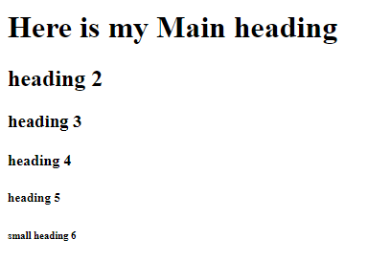

**What is the use Paragraph tag in HTML?**

HTML <p> tag is use for representing paragraph. If you want to write a paragraph in your html document then paragraph tag is used.

**For Example-**

<!DOCTYPE html>

<html>

<head>

<title>Paragraph tag</title>

</head>

<body>

<p> This is an example of paragraph tag. If you want to write a paragraph in your html document then paragraph tag is used </p>

</body>

</html>

**Output –**

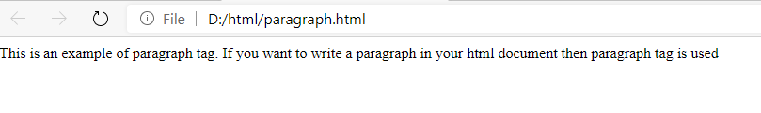

**What is the use Link tag in HTML and how it is represents in the web page –**

In HTML document, link tag is use to provide a link between two pages. It will take you on the same page which you have mention as a link in the given tag. <a> tag use to represent hyperlink which is also known as anchor tag. Anchor tag is having HREF as an attribute. **HREF** strands for **“hypertext reference”** which is use for give a link of browser, file e-mail etc.

**For Example-**

<head>

<title>link tag</title>

</head>

<body>

<a href=example.com>click here to go on link</a>

</body>

</html>

**Output –**

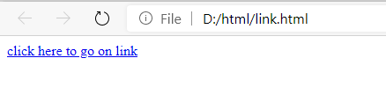

**What is the use of Image tag in html?**

Html Image tag is use for Inserting an image into your html Page. Images are not diectly inserted into your html page but it is lincked with the web page. Image tag consist of src attribute which helps html content to specifies the url of the image.

< img src="D:\html\images\nature.png" width="700" height="500" >

For Example-

<html>

<head>

<title>Image tag</title>

</head>

<body>

< img src="D:\html\images\nature.png" width="700" height="500" >

</body>

</html>

**Output** –

